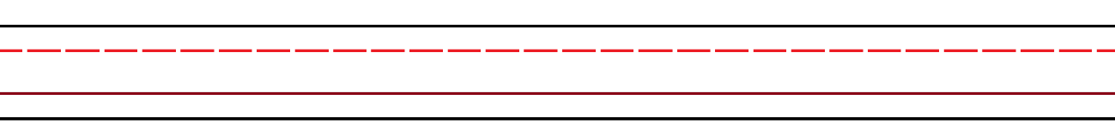

Aa Aa
Bb Bb
Bb
Aa
Bb
Aa








Dd
Cc



Dd Dd
Cc Cc
Ff
Ee
Dd
Cc









Ff Ff
Ee Ee








Ff
Ee


Hh Hh
Gg Gg
Hh
Gg
Hh
Gg








Jj
Ii



Ii Ii
Jj Jj
Ll
Ll
Kk
Jj
Ii









Kk Kk
Ll Ll








Kk


Nn Nn
Mm Mm
Nn
Mm
Mm
Nn








Pp
Oo



Oo Oo
Pp Pp
Rr Rr
Rr
Qq
Pp
Oo









Qq Qq








Rr
Qq


Tt Tt
Ss Ss
Tt
Ss
Tt
Ss








Vv
Uu



Uu Uu
Vv Vv
Xx
Ww
Uu
Vv









Ww Ww
Xx Xx








Ww
Xx


Yy Yy
Zz Zz
Zz
Yy
Yy
Zz








Uppercase Letters


ABCDEFGHIJKLMNOPQRSTUVWXYZ







Lowercase Letters


abcdefghijklmnopqrstuvwxyz







